ASSIGNMENT-9.2
AI ASSISTANT CODING

NAME: Thrishala Jakkaraju
BATCH: 22
HTNO:2303A51514

Task Description -1 (Documentation – Function Summary
Generation)
Task:
Use AI to generate concise functional summaries for each Python
function in a given script.
Instructions:
• Provide a Python script to the AI.
• Ask the AI to write a short summary describing the purpose of
each function.
• Ensure summaries are brief and technically accurate.
• Do not include code implementation details.
Expected Output -1:
A Python script where each function contains a clear and concise
summary explaining its purpose.Code:
Output:
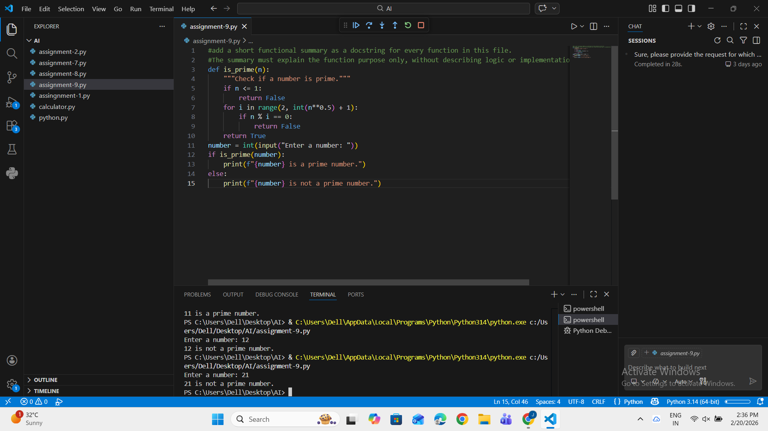
Observation:
AI-generated function summaries help improve code readability by clearly describing the
purpose of each function. The summaries make it easier for developers to understand the
program structure without analyzing the implementation details. This approach also
supports faster maintenance and documentation consistency.
Task Description -2 (Documentation – Logical Explanation for
Conditions and Loops)
Task:
Use AI to document the logic behind conditional statements and loops in
a Python program.
Instructions:• Provide a Python program without comments.
• Instruct AI to explain only decision-making logic and loop
behavior.
• Skip basic syntax explanations.
Expected Output -2:
Python code with clear explanations describing the logic of conditions
and loops.
Output:
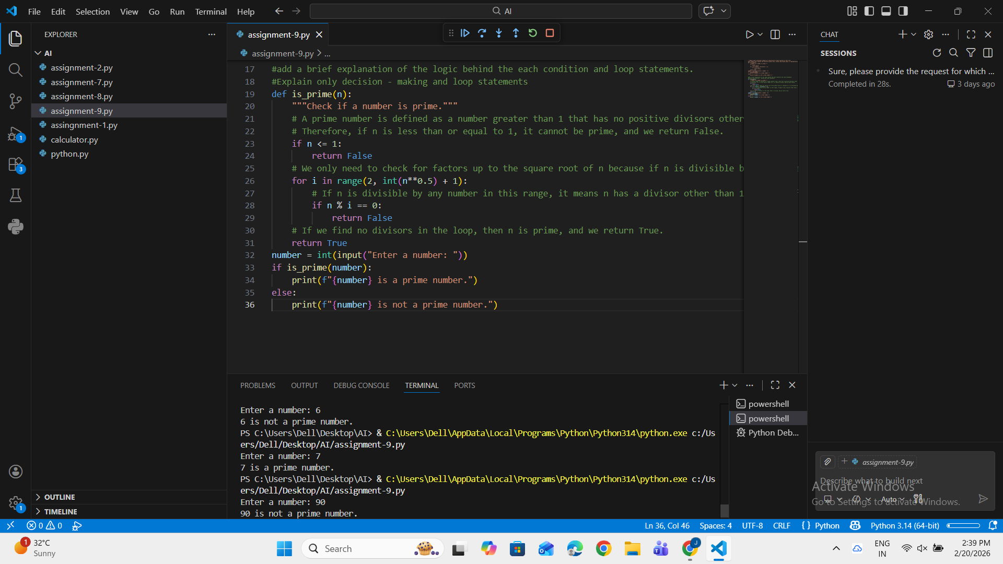
Observation:
AI-generated explanations for conditions and loops clarify the decision-making flow and
iteration behavior within the program. These logical comments help users quickly
understand how the program controls execution paths. As a result, debugging and code
comprehension become more efficient.Task Description -3 (Documentation – File-Level Overview)
Task:
Use AI to generate a high-level overview describing the functionality of
an entire Python file.
Instructions:
• Provide the complete Python file to AI.
• Ask AI to write a brief overview summarizing the file’s purpose
and functionality.
• Place the overview at the top of the file.
Expected Output -3:
A Python file with a clear and concise file-level overview at the
beginning.
Output:
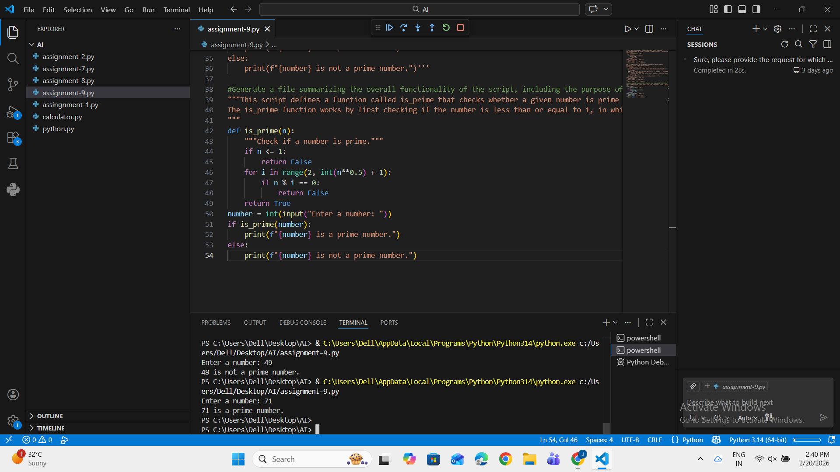
Observation:The AI successfully generated a concise file-level overview summarizing the
overall purpose and functionality of the Python program. The overview was placed at the
beginning of the file and described the program at a conceptuallevel without including
implementation details. This improved the readability of the code and helped users quickly
understand the program’s objective.
Task Description -4 (Documentation – Refine Existing
Documentation)
Task:
Use AI to improve clarity and consistency of existing documentation in
Python code.
Instructions:
• Provide Python code containing basic or unclear comments.
• Ask AI to rewrite the documentation to improve clarity and
consistency.
• Ensure technical meaning remains unchanged.

Expected Output -4:
Python code with refined and improved documentation that is clear and
consistent.
Output:
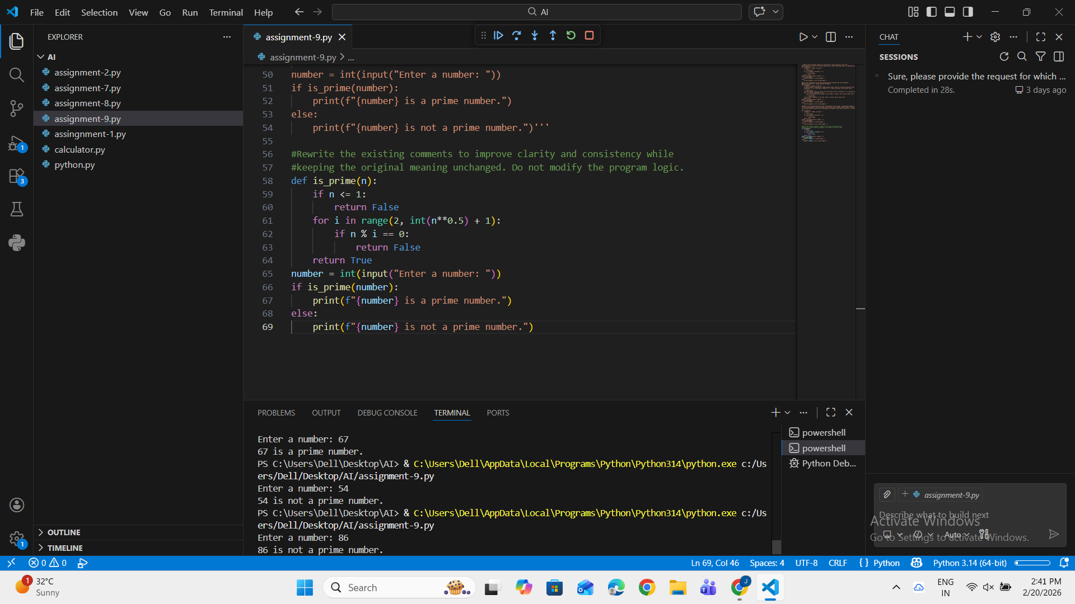
Observation:The AI improved the clarity and consistency of the existing comments without
altering the program’s functionality. The refined documentation provided clearer
explanations while preserving the original technical meaning. This enhancement made the
code easier to read, understand, and maintain.
Task Description -5 (Documentation – Prompt Detail Impact Study)
Task:
Study the impact of prompt detail on AI-generated documentation
quality.
Instructions:
Create two prompts: one brief and one detailed.
• Use both prompts to document the same Python function.
• Compare the generated outputs.Expected Output -5:
A comparison table highlighting differences in completeness, clarity, and
accuracy of documentation.
Output:
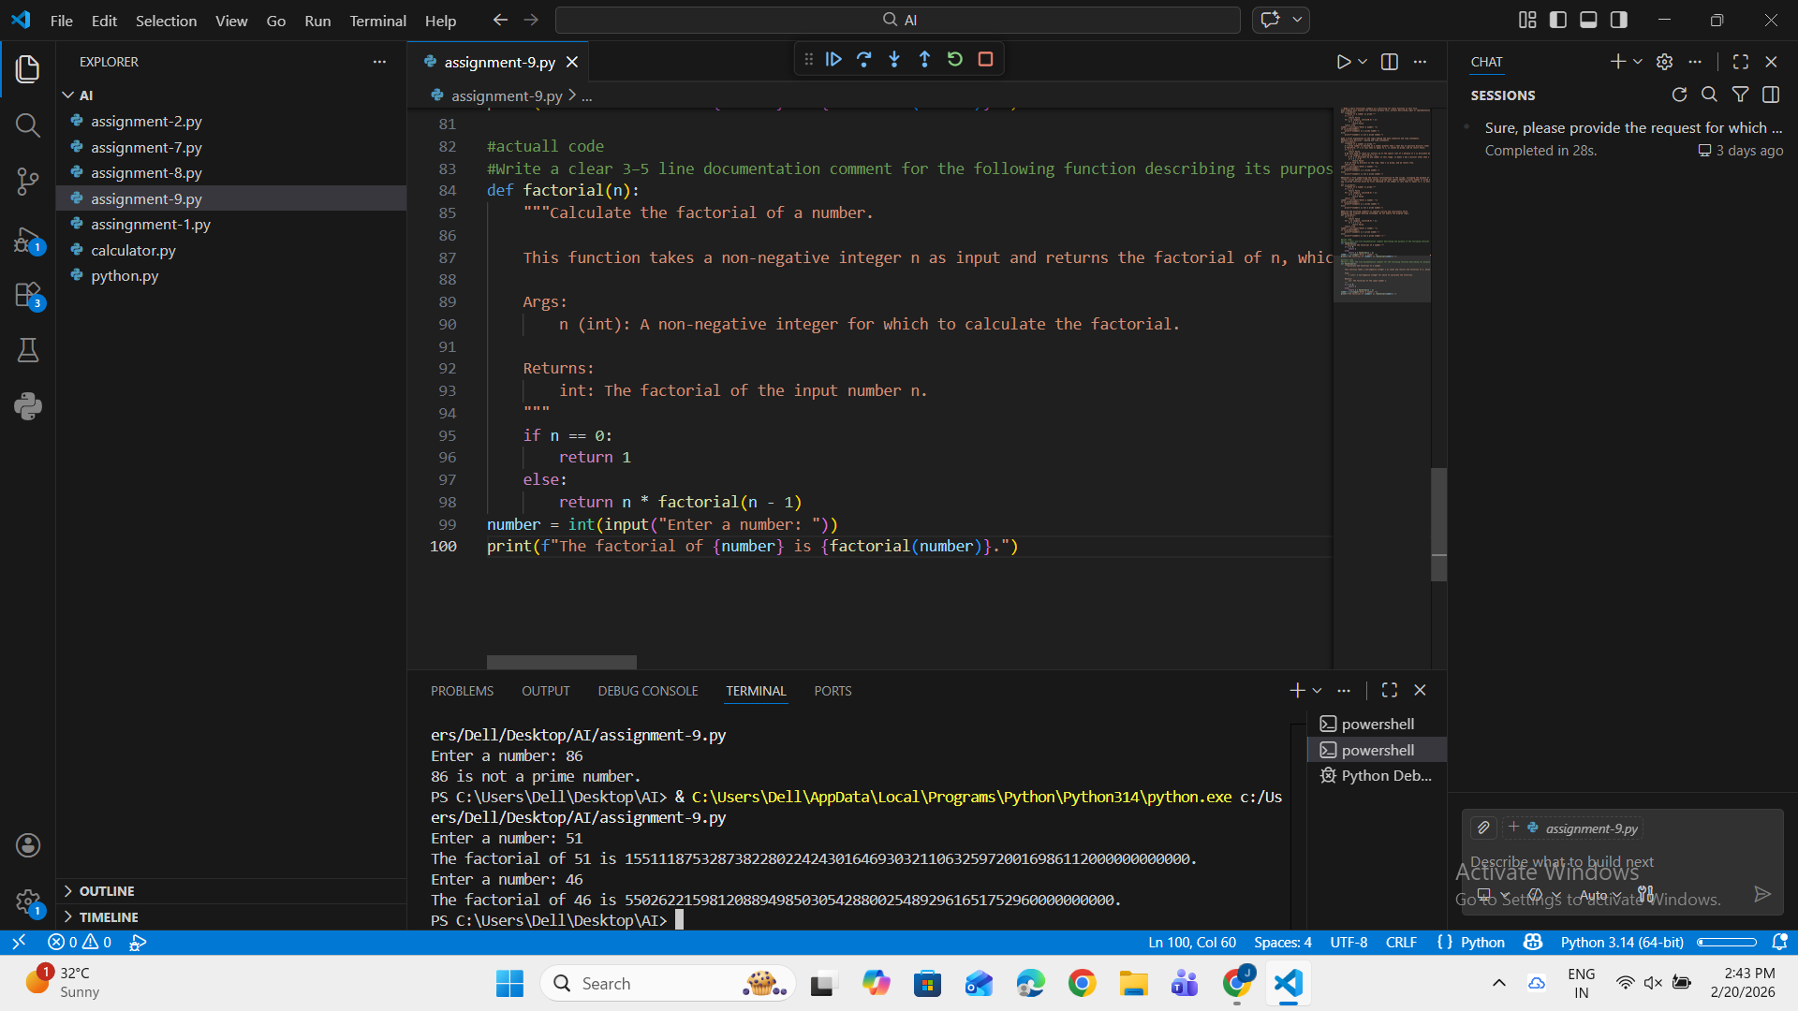
Observation:Criteria
Brief Prompt Output (One
line Comment)
Detailed Prompt Output (3–5 line
Docstring)
Completeness
Provides only the basic purpose
of the function.
Includes purpose, input description,
output, and behavior details.
Clarity
Clear but very minimal
explanation.
More descriptive, structured, and easier
to understand.
Accuracy
Correct but limited
technical information.
Highly accurate with full technical
context and parameter details.

